COMSATS University Islamabad,

COMSATS Road, Off G.T Road, Sahiwal, Pakistan

Software Requirements Specification

(SRS Document)

***for***



Her Amigo

Version 1.0

***By***

Ayesha Iftikhar

FA17-BSE-011

Bachelor of Science in Software Engineering (2017-2021)

Table of Contents

1. Introduction 1

1.1. Purpose 1

1.2. Scope 1

1.3. System Overview 2

1.4. References 2

2. Definitions 3

3. Use Cases 3

3.1. Use Case Description 5

4. Functional Requirements 7

4.1. Emergency Button 7

4.2. Add Contacts 7

4.3. Consultancy 7

4.4. Awareness Documents 7

4.5. Safety Tips and Tricks 8

4.6. Emergency Helplines 8

4.7. Nearest Clinics 8

4.8. Consultant Panel 8

4.9. Admin Panel 8

5. Non-Functional Requirements 8

5.1. Usability 8

5.2. Performance 9

5.3. Security 9

5.4. Availability 9

5.5. Maintainability 9

5.6. Integrity 9

5.7. Portability 9

Table of Tables

Table 1: Definitions 3

Table 2: Use Case Description- Getting Consultancy 5

Table 3: Use Case Description- Emergency Button 6

Table of Figures

Figure 1: Use Case-Users 3

Figure 2: Use Case-Admin & Consultants 4

# Introduction

Women are exploring themselves in various areas globally and facing many challenges and threats in their lives. Women's security has become a significant concern in recent times. She always needs some appropriate consultancy for health or business purposes, which is not common in our society. That causes women many sufferings, and sometimes, she got into depression or some other bad situation. This app reduces risk and brings assistance. When we need it in an emergency? We are all aware of the importance of women's safety, but we realize that they should be adequately protected. Women are not as physically strong as men. In an emergency, a helping hand would be a relief for them, in light of the recent outrage in Pakistan that shook the nation and woke us to our women's safety issues.

## Purpose

Her Amigo is an app that will provide great help in a woman's life, whether she is traveling somewhere or just staying at her home. It is developed as an effort for women's safety and facility. When she needs to consult a doctor, psychiatrist, or business expert, she can quickly get the nearest consultant's location. The consultants can register to the app and provide their services to her. Using this app, she will know about her rights provided by the government of Pakistan and emergency helplines and safety measures that she should know for keeping herself safe. This is an application built for android/iOS handheld devices. The proposed system is developed to overcome the disadvantages of the existing system specified earlier. We can create interactive women's safety and facility user applications using a mobile application. Her Amigo has an emergency button that allows the user to press when she is in an unfavorable situation—pushing this button intimates to her emergency contacts.

## Scope

Women can face any emergency or problem anytime. We can develop a solution that will help them get out of that problem. It is still challenging for women to step out from their homes or seek some proper consultancy about their country's issues. That is why we propose a system that will help women seek help or consultancy when they need it. This app's primary purpose is to provide women with a platform to seek help quickly in an emergency and get the consultancy if she feels like she needs it. This app will be available for women of every age, and it, for sure, makes their life easy when they are traveling somewhere alone. It will provide consultancy and information about the nearest clinics to visit them in serious situations. This will also provide the women safety tips and tricks along with awareness documents and emergency helplines. It is a mobile application that will be easy to access and use, and it is a virtual emergency and help center for females. Thus, the project is flexible and can be improved at any time with more advanced features.

## System Overview

Overall, the system is an entirely new product that will cover multiple functionalities. The application will replace the existing emergency help applications for women and provide gynecologists and psychiatrists. It will cover the women rights provided by the government of Pakistan as well as security tips and tricks. The application can be used worldwide, but it will take its initiative in Pakistan, where it is being developed. It helps countries where women hardly go out of their houses if they need any help and find difficulty in getting emergency assistance. The application will operate on both android and IOS devices. It will use the device's GPS to get location information. Some RAM and storage space will be required for its proper running. Some functions of the app will require the internet. So, unavailability of the internet might restrict some of its functionality to be used.

## References

Women Safety ,Punjab Safe Cities Authority (2020), PSCA(3.2.0) [Mobile App]. Google Play Store, <https://play.google.com/store/apps/details?id=com.psca.ppic3.womensafety>

Women Safety Tips, XenApp (2019), Jeen(1.8.0) [Mobile App]. Google Play Store, <https://play.google.com/store/apps/details?id=com.andromo.dev626242.app603504>

Sister, Wave App S.L. (2020), WASL(2.2.0) [Mobile App]. Google Play Store, <https://play.google.com/store/apps/details?id=com.wavelt.sister>

Emergency SOS safety Alert, appCDM (2019), CDM(0.36) [Mobile App]. Google Play Store, <https://play.google.com/store/apps/details?id=com.clarity.eap.alert>

# Definitions

|  |  |
| --- | --- |
| iOS | I phone’s Operating System, operating system used in iPhone |
| RAM | Random Access Memory, temporary memory which holds all the data and resources for processing. |
| GPS | Global Positioning System, an accurate worldwide navigational and surveying facility based on the reception of signals from an array of orbiting satellites. |

Table 1: Definitions

# Use Cases

Figure 1: Use Case-Users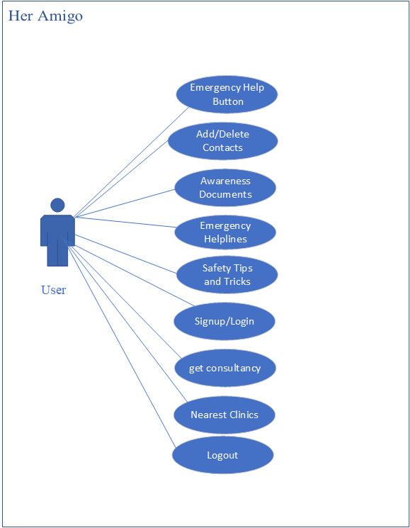

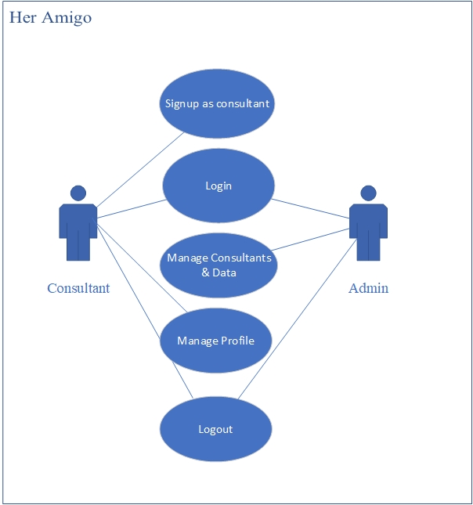

Figure 2: Use Case-Admin & Consultants

## Use Case Description

We are going to briefly describe two use cases. If user need more details of use cases, they can ask for it.

Table 2: Use Case Description- Getting Consultancy

|  |  |
| --- | --- |
| **Use Case-ID** | HA-01 |
| **Use Case Name** | Getting Consultancy |
| **Actors** | User |
| **Description** | The user wants to get consultancy virtually using Her Amigo. |
| **Triggers** | User Clicks on Consultancy Button/Tab. |
| **Pre-Conditions** | The system should have a proper internet connection. |
| **Post-Conditions** | The user connects with the required consultant and set up the session. |
| **Normal Flow** | The user will open the app.  The system will display the user interface of the app.  The user will click on the consultancy tab.  Two options related to consultancy appears.  The user clicks on the desired option.  Login screen appears  Users enter the credentials to log in.  After login, a list of consultants will appear.  Users select one consultant and contact them; then she gets the consultancy about the concerned matter. |
| **Alternative Flow** | The user needed to register before logging in.  Users need to change the password or get access to its account again.  Users can contact more than one consultant at a time.  Users can get both types of consultancies at any time. |
| **Business Rules** | **BR-1:** The user needs to be registered to use this feature and all the related features. |
| **Assumptions** | Assume that if a user is connected with multiple consultants, she will get notified about the new consultants in town. |

Table 3: Use Case Description- Emergency Button

|  |  |
| --- | --- |
| **Use Case-ID** | HA-02 |
| **Use Case Name** | Emergency Button |
| **Actors** | User |
| **Description** | Users want to send an emergency alert for help in case of emergency |
| **Triggers** | User Clicks on Consultancy Button/Tab. |
| **Pre-Conditions** | The system should be installed and have given all the necessary permissions. |
| **Post-Conditions** | Emergency Alert sent successfully. |
| **Normal Flow** | The user will open the app.  The system will display the user interface of the app.  The user will click on the emergency button.  A predefined message is sent to the trusted contacts added by the user. |
| **Alternative Flow** | Users can send an emergency alert to multiple persons at a time. |
| **Business Rules** | **BR-1:** system should have location permission to access the exact location of the system.  **BR-2:** The contact number of the trusted person should be the one which they used. |

# Functional Requirements

The system has the following main modules:

## Emergency Button

* The app provides the facility of an emergency button and to add up to 3 reliable contacts.
* In case of emergency, the user will click the button, and her location will be sent via text message to those contacts that will alert them about users, and they can reach to help immediately.

## Add Contacts

* The user can add a contact using this module on which the system will send a message in case of an emergency.

## Consultancy

* This module will provide women consultancy as they hesitate to discuss their health-related or psychic issues.
* This system will provide two types of consultancies as follows:
  + Gynecologists
  + Psychiatrists
* She can contact them on the app or can make an appointment with them and meet them personally.

## Awareness Documents

* This module will provide all the laws of Pakistan, which are entirely related to women.
* These documents will help her to stand for herself to get her rights.
* It will also provide the necessary information about the most unfavorable situations.

## Safety Tips and Tricks

* This module will provide the user with all the essential tips and tricks which a woman should know for her safety.
* It is partially offline because it will have some video tutorial links embedded with the text for easy training.

## Emergency Helplines

* This module will have a list of all emergency helpline numbers provided by the government of Pakistan.
* Users can quickly call on these numbers by staying in the application.

## Nearest Clinics

* This module gets the user's live location and shows them all the nearest clinics of medical consultants and business advisors within their city premises.

## Consultant Panel

* The consultants will be able to edit their profile by themselves
* If they have changed their respective information like where their clinic, their contact information, or anything like that.

## Admin Panel

* Admin can login to system using valid credentials.
* He/ She can add or remove users specially consultants.
* They will be managing all the data and resources provided by app.

# Non-Functional Requirements

## Usability

* This app will help in saving time and improving efficiency for the users.
* This app will also provide the facility to help women with their emergency time.

## Performance

* The performance of the application is excellent.
* This app is very reliable to use for the security of women.
* It performs all the tasks very correctly.
* Provides all the results quickly and accurately.

## Security

* There are some modules in Her Amigo App, i.e., Gynecologist, Psychiatrist, that requires a login for the consultancy.
* If someone needs consultancy, this system will provide a proper way/instruction and ensure only authorized users can access their data.

## Availability

* The app will always be in a responsive state when it is needed.
* It will provide the desired functionality accordingly, without any error and delay.

## Maintainability

* The app will maintain its functionality and can improve if any defect is being found.

## Integrity

* The application will ensure that all of its functions work correctly.
* It is providing the desired functionality consistently.

## Portability

* Her Amigo is an iOS and android app.
* The minimum iOS software version for this app is 11.0.
* The minimum android software version for this app is 7.0 (Nougat).